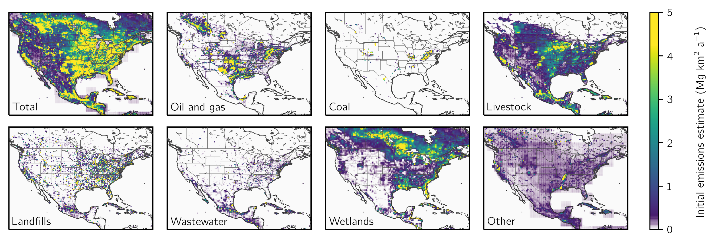

**Figure 1:** Bottom-up methane emission inventories used as prior estimates for the inversion. Panels show mean annual methane emissions for different sectors from the gridded versions of the official anthropogenic inventories for the US (EPA GHGI), Canada (ECCC), and Mexico (INECC), and the high-performance subset of the WetCHARTs inventory ensemble for wetlands (Ma et al., 2021). Emissions are shown on the 0.25° ⨉ 0.3125° GEOS-Chem grid used for the inversion.

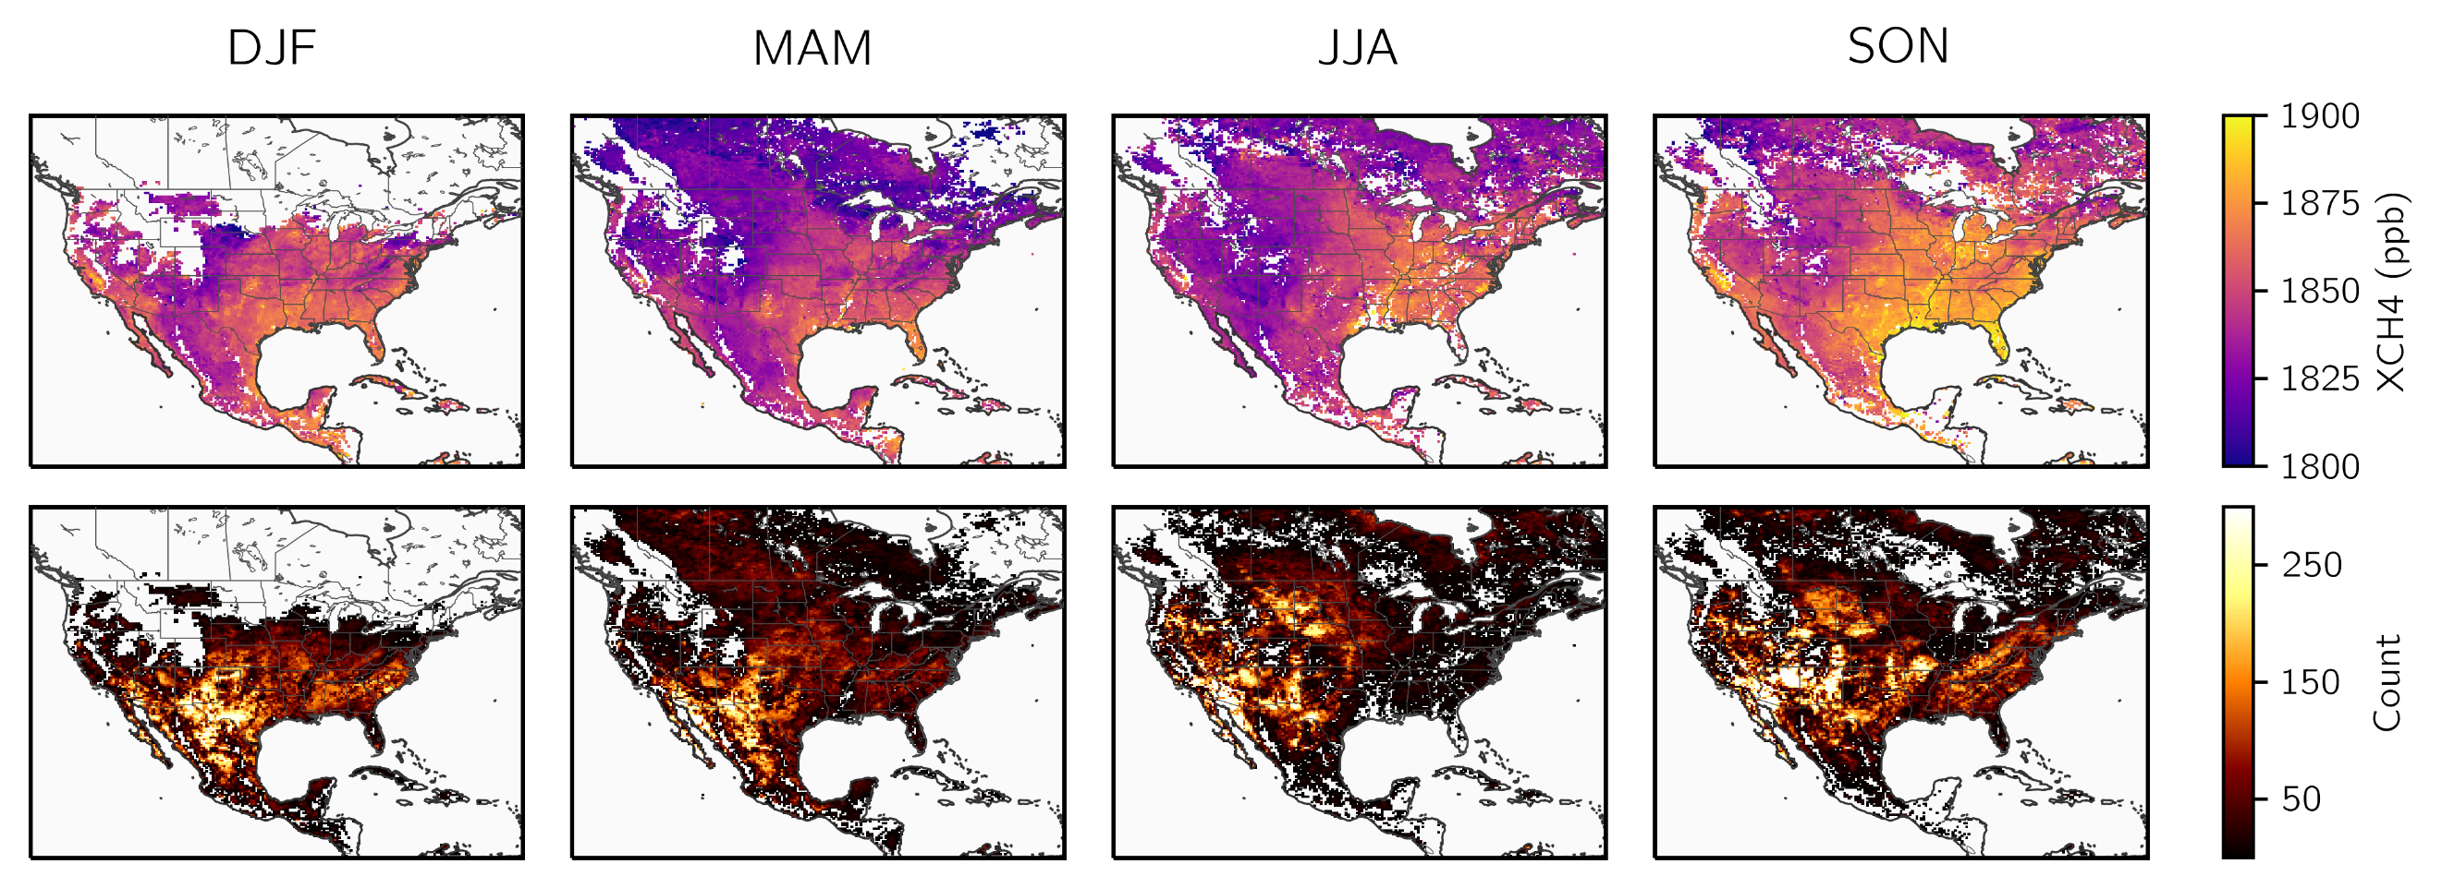

**Figure 2:** TROPOMI methane observations in 2019. The top row shows the seasonal average column dry methane mixing ratios (XCH4) averaged on the 0.25° ⨉ 0.3125° GEOS-Chem. The bottom row shows the observational density on the same grid. The observations have been filtered as described in section 2.4.

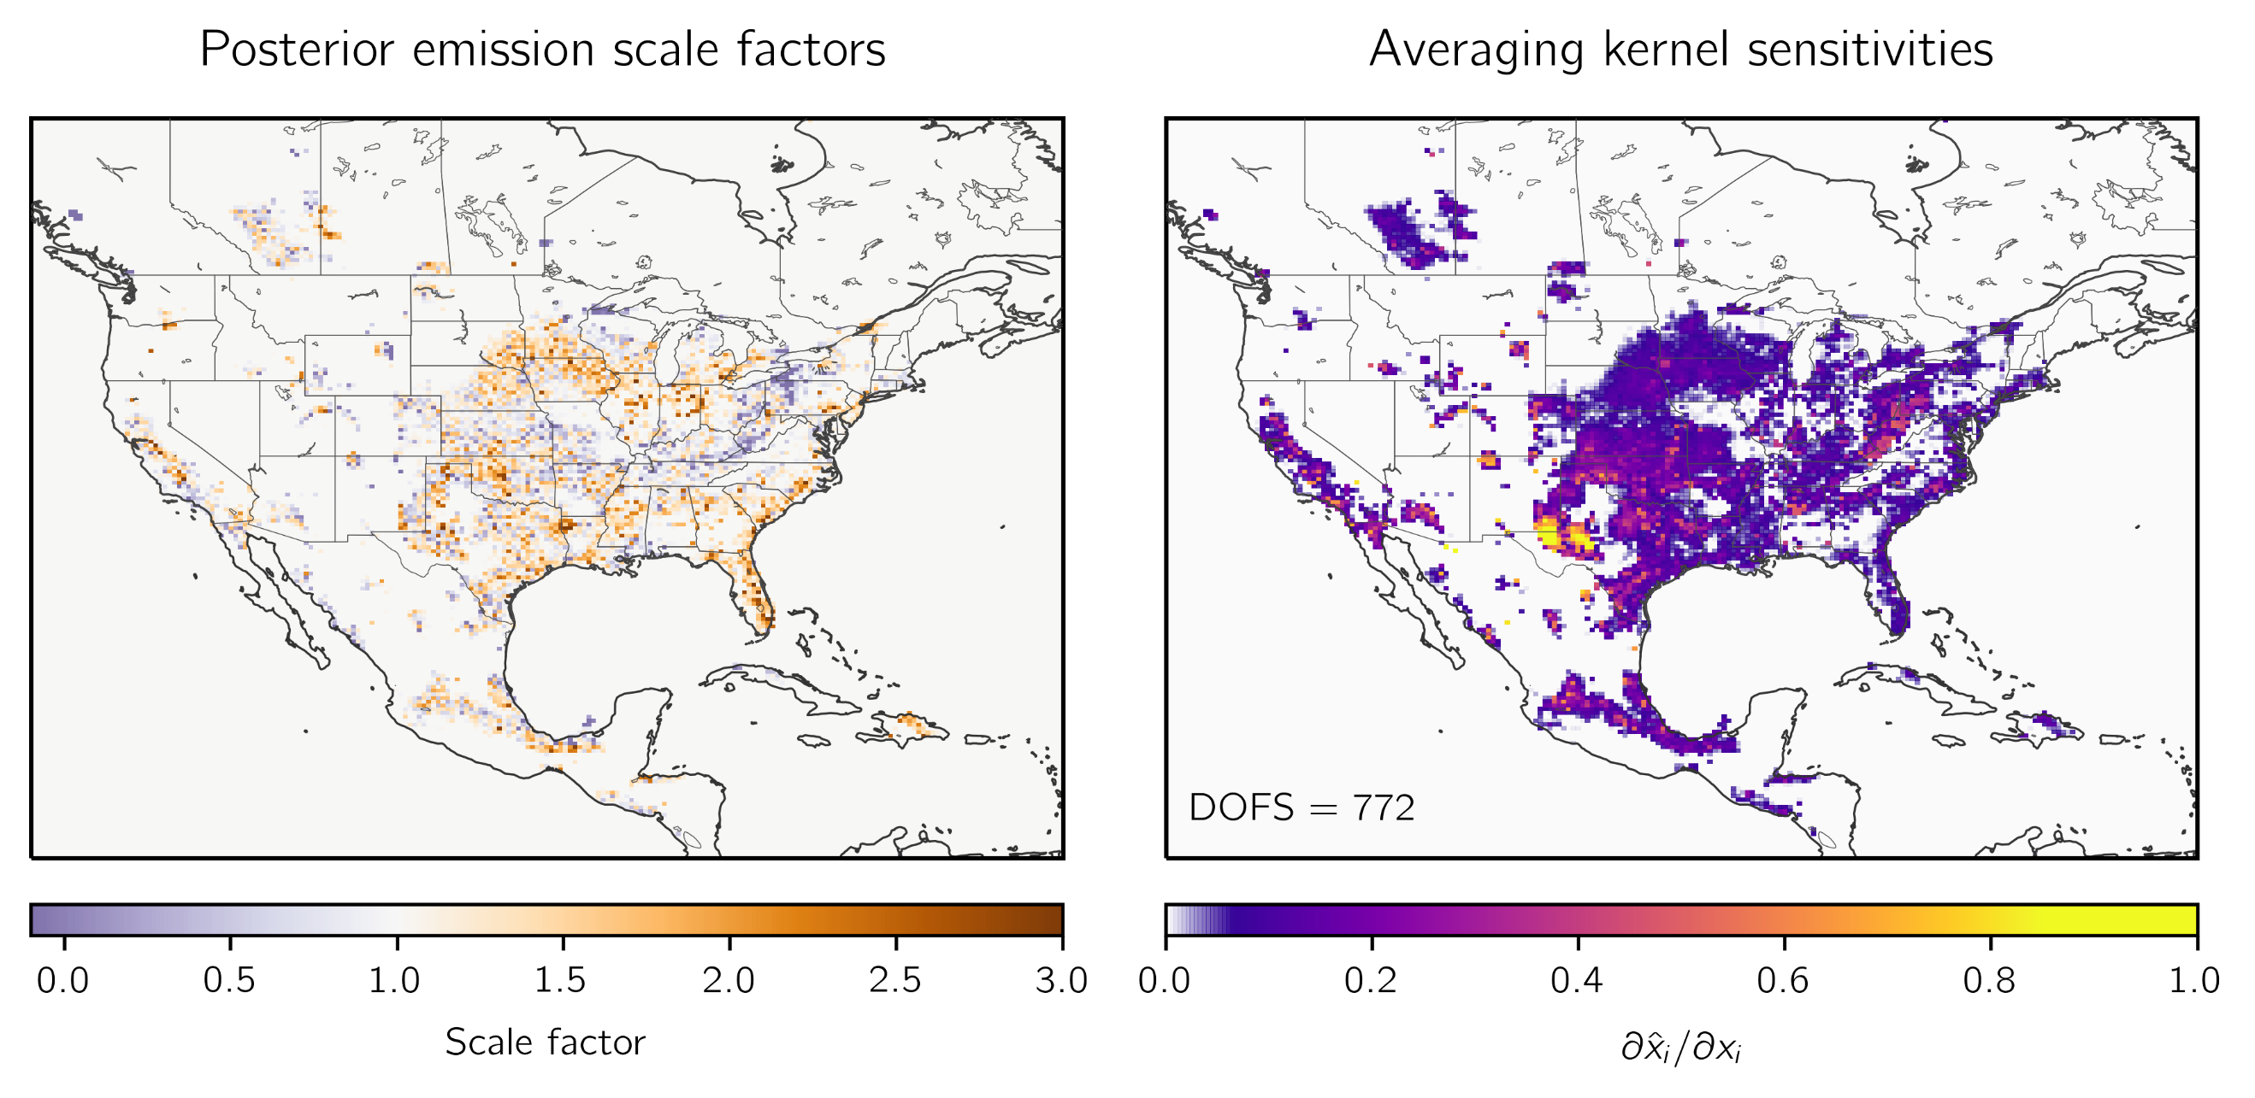

**Figure 3:** Optimization of 2019 methane emissions by inversion of TROPOMI observations. The left panel shows the correction factors relative to the gridded versions of the national emissions inventories for Canada (ECCC), the U.S. (EPA GHGI), and Mexico (INECC) used as prior estimates for the inversion (Figure 1, top left panel). The right panel shows the observing system information content as measured by the averaging kernel sensitivities (the diagonal elements of the averaging kernel matrix). Values of 1 indicate that TROPOMI fully quantifies emissions independently of the prior estimate, while values of 0 indicate default to the prior. The sum of aeraging kernel sensitivites gives the degrees of freedom for signal (DOFS), shown inset, which defines the number of pieces of information independently quantified by the observing system.

**Figure 4:** Optimization of 2019 sectoral methane emissions in the contiguous United States (CONUS) by inversion of TROPOMI observations. Prior (top) and posterior (bottom) emissions are shown for livestock, oil and gas, coal, landfills, wastewater, other anthropogenic emissions, and wetlands. The dark shading corresponds to emissions that occur in grid cells where the observing system provides useful constraints (averaging kernel sensitivities greater than 0.05), while the light shading represents emissions occurring in the remaining grid cells where the posterior estimate defaults to the prior. Error bars on the posterior emissions are given by the spread of an eight-member inversion ensemble. Also shown are bottom-up sectoral estimates for 2019 from the EPA GHGI (2022) and previous inversion results from Lu et al. (2022) and Shen et al. (2022).

**Figure 5:** Anthropogenic methane emissions for the 29 states in the contiguous United States (CONUS) responsible for 90% of total national posterior emissions. The bottom panel shows prior (left bar) and posterior (right bar) anthropogenic methane emissions divided by sector, including livestock, oil and natural gas, coal, landfills, wastewater, and other sources. States are listed from largest to smallest posterior emissions. The information content as defined by the reduced-form averaging kernel sensitivities (the diagonal elements of the reduced-form averaging kernel matrix; section 2.8) is shown in the top panel. The error bars give the spread of the state totals from the eight-member inversion ensemble. Also shown in the Figure are emission inventories for individual states as reported in the latest version of the EPA GHGI (2022) and independently constructed state inventories

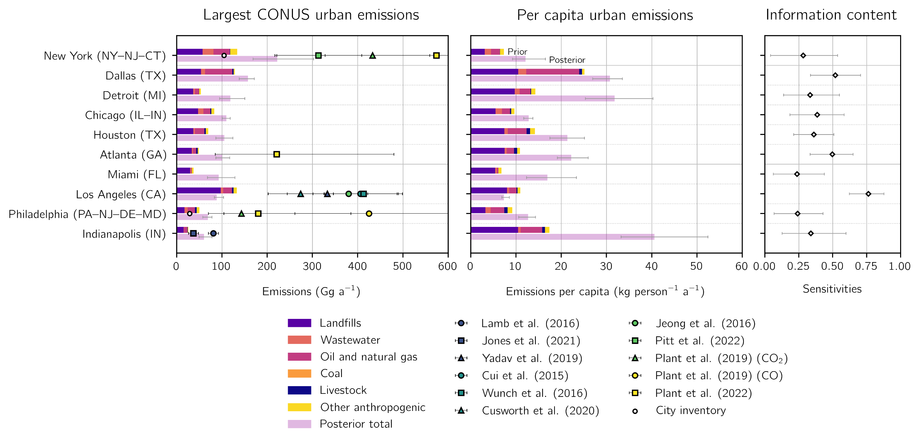

**Figure 6:** Anthropogenic methane emissions for the largest 10 methane-producing urban areas in the contiguous United States (CONUS). Urban area extents are defined by the U.S. Census Bureau TIGER/Line files. The top bars show prior estimates from the gridded EPA inventory for individual sectors, and the bottom bars show posterior results from the TROPOMI inversion for 2019. Total emissions, per capita emissions, and averaging kernel sensitivities are shown for each urban area. We do not resolve sectors in the posterior emission estimates because of insufficient spatial resolution. Error bars represent the spread of the eight-member inversion ensemble. Also shown are independent urban emission estimates.

**Figure 7:** Livestock (TBD)

**Table 1:** The 8 members of the inversion ensemble.

|  |  |  |  |  |
| --- | --- | --- | --- | --- |
| **Optimized boundary conditions**1 | **Latitude correction**2 | **Regularization factor**3 | **Prior error standard deviation** | **Optimized grid cells**4 |
| Yes | Yes | 0.2 | 50% | 3692 |
| 0.45 | 0.75 | 5661 |
| Yes | No | 0.175 | 0.5 | 3435 |
| 0.3 | 0.75 | 5327 |
| 0.5 | 1 | 6067 |
| No | Yes | 0.175 | 0.5 | 3443 |
| 0.35 | 0.75 | 5476 |
| No | No | 0.175 | 0.75 | 4759 |

We conduct inversions that do and do not optimize the boundary conditions. In inversions with optimized boundary conditions, we include in the inversion state vector four boundary condition elements corresponding to the northern, eastern, southern, and western borders of the North American domain.

2 We also conduct inversions that do and do not correct the latitudinal bias in the model – observation difference with a first order polynomial. In inversions without a latitudinal correction, we remove the mean model – observation difference.

3 We balance the prior and observing system errors to avoid overfitting the emissions to the observations. The regularization factor $γ$ is applied to the inverse observational error covariance matrix $S_{O}^{-1}$ so that values less than one increase the observing system errors. We choose the values of the regularization factor following the chi-squared method described in section 2.7.

4 The number of grid cells optimized by the inversion, defined as the number of grid cells with sensitivity of the emissions to the observations greater than 0.05.

**Table 2:** 2019 methane emissions for the contiguous United States (CONUS).

|  |  |  |  |
| --- | --- | --- | --- |
|  | **Prior emissions**1 | **Posterior**  **emissions**2 | **Sensitivity**3 |
| **Total sources [Tg a-1]** | 36.5 | 39.3 (38.2 - 40.3) |  |
| **Anthropogenic sources** | 28.7 | 30.9 (30.0 - 31.8) |  |
| Livestock | 9.2 | 10.4 (10.0 - 10.7) | 0.66 (0.55 - 0.76) |
| Oil and natural gas | 9.4 | 10.4 (10.1 - 10.7) | 0.91 (0.88 - 0.95) |
| Coal | 2.9 | 1.5 (1.2 - 1.9) | 0.60 (0.45 - 0.80) |
| Landfills | 5.7 | 6.9 (6.4 - 7.5) | 0.47 (0.34 - 0.64) |
| Wastewater | 0.6 | 0.6 (0.5 - 0.7) | 0.33 (0.16 - 0.60) |
| Other anthropogenic | 0.9 | 1.1 (1.0 - 1.2) | 0.59 (0.44 - 0.76) |
| **Natural sources** | 7.8 | 8.4 (8.1 - 8.6) |  |
| Wetlands | 6.6 | 7.2 (7.0 - 7.4) | 0.35 (0.16 - 0.55) |
| Other biogenic | 1.1 | 1.2 (1.2 - 1.2) | 0.25 (0.19 - 0.32) |

1Prior emission estimates for the inversion. Anthropogenic emissions are from the gridded version of the Environmental Protection Agency (EPA) Inventory of U.S. Greenhouse Gas Emissions and Sinks (GHGI) for 2012. Oil and natural gas emissions are updated following Shen et al. (2022) to match 2018 infrastructure and GHGI emissions data. Wetland emissions are from a subset of the high performance WetCHARTs ensemble version 1.3.1. See section 2.2 for more details.

2Optimized emissions from the inversion of TROPOMI data, with the range from the eight members of the inversion ensemble shown in parentheses.

3The sensitivity of the posterior emissions to the observing system as given by the diagonal elements of the sectoral averaging kernel matrix calculated as described in section 2.8. The parenthetical values give the range of the inversion ensemble. Values range from 0 (no sensitivity) to 1 (full sensitivity)

**Table S1:** 2019 methane emissions from the 48 states in the contiguous United States.

|  |  |  |  |  |  |  |  |  |  |  |  |  |  |  |  |
| --- | --- | --- | --- | --- | --- | --- | --- | --- | --- | --- | --- | --- | --- | --- | --- |
| **Emissions**  **(Gg a-1)**1 | **Livestock** | | **Oil and natural gas** | | **Coal** | | **Landfills** | | **Wastewater** | | **Other anthropogenic** | | **Total anthropogenic** | | |
| **State** | **x**A2 | **x̂**3 | **x**A | **x̂** | **x**A | **x̂** | **x**A | **x̂** | **x**A | **x̂** | **x**A | **x̂** | **x**A | **x̂**4 | **Sensitivity**5 |
| 1. Texas | 977 | 1165 | 3546 | 4299 | 17 | 24 | 480 | 627 | 44 | 48 | 85 | 110 | 5150 | 6274 (6101, 6454) | 0.94 (0.89, 0.97) |
| 2. California | 877 | 1104 | 191 | 231 | 0 | 0 | 508 | 514 | 51 | 58 | 138 | 148 | 1764 | 2055 (1970, 2122) | 0.86 (0.75, 0.93) |
| 3. Oklahoma | 333 | 399 | 636 | 894 | 13 | 20 | 108 | 121 | 3 | 3 | 6 | 6 | 1099 | 1444 (1384, 1511) | 0.86 (0.75, 0.92) |
| 4. Pennsylvania | 165 | 196 | 409 | 238 | 461 | 524 | 131 | 196 | 16 | 20 | 16 | 20 | 1197 | 1194 (1061, 1384) | 0.57 (0.35, 0.77) |
| 5. New Mexico | 213 | 211 | 946 | 925 | 39 | 32 | 64 | -34 | 2 | 2 | 4 | 3 | 1267 | 1139 (1100, 1180) | 0.96 (0.93, 0.98) |
| 6. Louisiana | 63 | 79 | 431 | 731 | 2 | 2 | 104 | 126 | 7 | 9 | 114 | 174 | 721 | 1121 (1010, 1258) | 0.55 (0.28, 0.76) |
| 7. Iowa | 621 | 793 | 37 | 59 | 0 | 0 | 72 | 116 | 8 | 13 | 5 | 7 | 743 | 989 (952, 1010) | 0.75 (0.54, 0.88) |
| 8. Illinois | 153 | 191 | 87 | 121 | 209 | 170 | 237 | 368 | 28 | 37 | 17 | 21 | 731 | 907 (862, 944) | 0.55 (0.29, 0.79) |
| 9. Florida | 164 | 250 | 18 | 26 | 0 | 0 | 297 | 540 | 11 | 15 | 30 | 47 | 521 | 878 (699, 1106) | 0.32 (0.04, 0.58) |
| 10. Kansas | 440 | 448 | 338 | 358 | 0 | 0 | 84 | 41 | 11 | 9 | 4 | 3 | 878 | 860 (839, 888) | 0.80 (0.66, 0.89) |
| 11. Colorado | 255 | 232 | 376 | 351 | 176 | 102 | 113 | 110 | 4 | 4 | 6 | 5 | 930 | 804 (740, 861) | 0.59 (0.44, 0.72) |
| 12. Michigan | 160 | 187 | 113 | 121 | 0 | 0 | 268 | 392 | 11 | 19 | 16 | 22 | 568 | 742 (674, 813) | 0.49 (0.16, 0.74) |
| 13. Alabama | 102 | 109 | 113 | 120 | 165 | 154 | 238 | 259 | 21 | 25 | 10 | 11 | 649 | 677 (629, 717) | 0.75 (0.55, 0.89) |
| 14. North Carolina | 252 | 375 | 24 | 23 | 0 | 0 | 183 | 225 | 123 | 17 | 11 | 13 | 593 | 654 (547, 744) | 0.48 (0.24, 0.71) |
| 15. Ohio | 143 | 146 | 195 | 160 | 94 | 32 | 252 | 244 | 22 | 24 | 16 | 16 | 723 | 622 (578, 673) | 0.63 (0.38, 0.82) |
| 16. Indiana | 127 | 170 | 45 | 60 | 82 | 79 | 163 | 274 | 10 | 17 | 11 | 16 | 438 | 616 (561, 676) | 0.54 (0.28, 0.74) |
| 17. Nebraska | 480 | 533 | 22 | 24 | 0 | 0 | 41 | 46 | 5 | 5 | 3 | 3 | 551 | 611 (604, 619) | 0.64 (0.48, 0.73) |
| 18. West Virginia | 31 | 26 | 240 | 182 | 816 | 360 | 49 | 32 | 2 | 2 | 6 | 4 | 1143 | 607 (485, 730) | 0.66 (0.46, 0.83) |
| 19. Arkansas | 124 | 122 | 105 | 134 | 9 | 13 | 93 | 106 | 8 | 10 | 189 | 218 | 527 | 605 (569, 636) | 0.74 (0.48, 0.86) |
| 20. Georgia | 109 | 127 | 32 | 47 | 0 | 0 | 218 | 374 | 5 | 9 | 12 | 18 | 376 | 575 (509, 655) | 0.58 (0.35, 0.73) |
| 21. Wisconsin | 380 | 407 | 15 | 16 | 0 | 0 | 103 | 114 | 9 | 8 | 13 | 14 | 519 | 559 (518, 595) | 0.47 (0.07, 0.70) |
| 22. Idaho | 319 | 317 | 10 | 11 | 0 | 0 | 165 | 219 | 1 | 2 | 3 | 3 | 499 | 551 (498, 596) | 0.63 (0.49, 0.76) |
| 23. Minnesota | 291 | 381 | 30 | 26 | 0 | 0 | 76 | 83 | 4 | 4 | 9 | 10 | 410 | 504 (475, 534) | 0.53 (0.13, 0.69) |
| 24. Mississippi | 86 | 104 | 97 | 132 | 3 | 6 | 87 | 134 | 16 | 24 | 17 | 23 | 307 | 423 (380, 478) | 0.53 (0.22, 0.75) |
| 25. New York | 170 | 139 | 84 | 47 | 0 | 0 | 140 | 154 | 35 | 43 | 19 | 23 | 448 | 405 (352, 445) | 0.30 (0.06, 0.50) |

|  |  |  |  |  |  |  |  |  |  |  |  |  |  |  |  |
| --- | --- | --- | --- | --- | --- | --- | --- | --- | --- | --- | --- | --- | --- | --- | --- |
| **Emissions**  **(Gg a-1)**1 | **Livestock** | | **Oil and natural gas** | | **Coal** | | **Landfills** | | **Wastewater** | | **Other anthropogenic** | | **Total anthropogenic** | | |
| **State** | **x**A2 | **x̂**3 | **x**A | **x̂** | **x**A | **x̂** | **x**A | **x̂** | **x**A | **x̂** | **x**A | **x̂** | **x**A | **x̂**4 | **Sensitivity**5 |
| 26. Kentucky | 152 | 143 | 92 | 68 | 202 | 69 | 108 | 105 | 4 | 4 | 7 | 7 | 566 | 395 (347, 449) | 0.64 (0.40, 0.82) |
| 27. South Dakota | 292 | 347 | 9 | 12 | 0 | 0 | 13 | 18 | 5 | 12 | 2 | 2 | 322 | 392 (376, 401) | 0.38 (0.11, 0.53) |
| 28. Missouri | 292 | 266 | 16 | 14 | 0 | 0 | 82 | 54 | 10 | 9 | 39 | 24 | 439 | 367 (339, 394) | 0.55 (0.29, 0.69) |
| 29. Virginia | 112 | 109 | 61 | 31 | 172 | 20 | 171 | 169 | 23 | 22 | 12 | 11 | 550 | 362 (299, 428) | 0.56 (0.35, 0.75) |
| 30. Tennessee | 136 | 122 | 38 | 40 | 3 | 2 | 156 | 132 | 23 | 20 | 8 | 7 | 364 | 322 (301, 349) | 0.60 (0.33, 0.77) |
| 31. Montana | 212 | 211 | 70 | 63 | 20 | 10 | 19 | 19 | 1 | 1 | 3 | 3 | 323 | 306 (292, 322) | 0.31 (0.22, 0.40) |
| 32. North Dakota | 123 | 124 | 137 | 141 | 6 | 6 | 25 | 26 | 2 | 2 | 2 | 2 | 294 | 300 (286, 317) | 0.59 (0.41, 0.70) |
| 33. Washington | 143 | 149 | 20 | 20 | 0 | 0 | 84 | 98 | 13 | 14 | 13 | 13 | 273 | 293 (269, 337) | 0.10 (0.04, 0.14) |
| 34. Utah | 102 | 105 | 134 | 49 | 119 | 79 | 51 | 49 | 0 | 0 | 3 | 3 | 408 | 285 (248, 336) | 0.74 (0.57, 0.87) |
| 35. Oregon | 126 | 132 | 18 | 23 | 0 | 0 | 87 | 111 | 2 | 3 | 8 | 8 | 241 | 276 (256, 304) | 0.08 (0.05, 0.11) |
| 36. Arizona | 142 | 141 | 41 | 41 | 2 | 2 | 86 | 72 | 4 | 4 | 4 | 3 | 279 | 263 (261, 266) | 0.80 (0.74, 0.84) |
| 37. South Carolina | 42 | 53 | 9 | 11 | 0 | 0 | 102 | 145 | 16 | 21 | 6 | 8 | 175 | 237 (220, 249) | 0.51 (0.20, 0.70) |
| 38. New Jersey | 4 | 4 | 34 | 51 | 0 | 0 | 74 | 116 | 21 | 35 | 19 | 27 | 151 | 233 (186, 294) | 0.28 (0.06, 0.52) |
| 39. Maryland | 27 | 28 | 20 | 20 | 4 | 4 | 60 | 57 | 5 | 4 | 8 | 7 | 125 | 120 (112, 126) | 0.26 (0.04, 0.45) |
| 40. Nevada | 49 | 49 | 9 | 9 | 0 | 0 | 30 | 30 | 2 | 2 | 2 | 2 | 92 | 93 (93, 93) | 0.00 (0.00, 0.00) |
| 41. Massachusetts | 5 | 4 | 20 | 17 | 0 | 0 | 55 | 48 | 6 | 4 | 8 | 7 | 93 | 80 (66, 93) | 0.15 (0.00, 0.35) |
| 42. Wyoming | 116 | 113 | 230 | 142 | 281 | -186 | 12 | 10 | 0 | 0 | 2 | 1 | 641 | 80 (-194, 279) | 0.68 (0.48, 0.86) |
| 43. Vermont | 27 | 29 | 0 | 0 | 0 | 0 | 12 | 13 | 1 | 1 | 3 | 3 | 43 | 46 (45, 49) | 0.02 (0.00, 0.07) |
| 44. Connecticut | 6 | 5 | 9 | 8 | 0 | 0 | 16 | 15 | 15 | 12 | 5 | 4 | 51 | 45 (35, 51) | 0.26 (0.01, 0.50) |
| 45. Maine | 10 | 10 | 2 | 2 | 0 | 0 | 20 | 20 | 1 | 1 | 6 | 6 | 39 | 38 (37, 39) | 0.00 (0.00, 0.00) |
| 46. New Hampshire | 5 | 5 | 1 | 1 | 0 | 0 | 17 | 16 | 1 | 1 | 3 | 3 | 27 | 25 (23, 27) | 0.03 (0.00, 0.08) |
| 47. Delaware | 4 | 4 | 2 | 2 | 0 | 0 | 5 | 8 | 5 | 5 | 1 | 2 | 17 | 20 (19, 22) | 0.12 (0.04, 0.23) |
| 48. Rhode Island | 1 | 1 | 4 | 4 | 0 | 0 | 13 | 11 | 2 | 2 | 1 | 1 | 22 | 18 (14, 21) | 0.19 (0.07, 0.34) |

Sectoral emissions in gigagrams per year (Gg a-1) for anthropogenic emission sources, including livestock, oil and natural gas, landfillls, wastewater, and other categories, including rice.

2The prior emissions for each state from the gridded version of the Environmental Protection Agency (EPA) Inventory of U.S. Greenhouse Gas Emissions and Sinks (GHGI) for 2012. Oil and natural gas emissions are updated to match 2018 infrastructure and 2018 emissions as reported by the 2020 GHGI for 2018, except over the Permian basin in Texas where we use a high-resolution inventory from the Environmental Defense Fund.

3Optimized sectoral anthropogenic emissions from an inversion of TROPOMI data.

4The total anthropogenic optimized emissions. Values in parentheses give the minimum and maximum of an ensemble of 8 inversions.

5The sensitivity of the total state posterior emissions to the observing system, given by the diagonal elements of the state averaging kernel matrix calculated. Values in parentheses give the ensemble range. Sensitivities range from 0 (unresponsive to the observing system) to 1 (fully responsive).

**Table S2:** Top 10 methane-producing urban areas in the contiguous U.S. (CONUS) for 2019.

|  |  |  |  |  |  |  |  |  |
| --- | --- | --- | --- | --- | --- | --- | --- | --- |
| **Urban area**1 | **Prior emissions (Gg a-1)**2 | | | | | **Posterior emissions** | | |
| **Landfills** | **Wastewater** | **Oil and natural gas** | **Livestock** | **Other anthropogenic** | **Total (Gg a-1)** | **Per capita**  **(kg person-1 a-1)**4 | **Sensitivity**5 |
| New York-Newark, NY-NJ-CT | 57.24 | 24.33 | 35.90 | 0.68 | 15.72 | 222 (169, 302) | 12.10 | 0.28 (0.04, 0.54) |
| Dallas-Fort Worth-Arlington, TX | 53.78 | 8.99 | 59.82 | 3.37 | 2.78 | 157 (138, 172) | 30.80 | 0.52 (0.34, 0.70) |
| Detroit, MI | 36.26 | 4.04 | 8.93 | 0.53 | 3.63 | 119 (95, 150) | 31.80 | 0.33 (0.14, 0.55) |
| Chicago, IL--IN | 47.31 | 11.97 | 15.25 | 2.12 | 6.54 | 110 (101, 118) | 12.80 | 0.38 (0.18, 0.58) |
| Houston, TX | 36.86 | 3.51 | 20.72 | 3.55 | 5.37 | 106 (86, 124) | 21.30 | 0.36 (0.21, 0.51) |
| Atlanta, GA | 33.69 | 2.22 | 7.36 | 3.06 | 2.68 | 100 (86, 117) | 22.20 | 0.50 (0.33, 0.65) |
| Miami, FL | 29.75 | 2.04 | 1.55 | 0.41 | 3.54 | 93 (68, 128) | 16.90 | 0.24 (0.06, 0.44) |
| Los Angeles-Long Beach-Anaheim, CA | 97.40 | 5.68 | 19.18 | 3.24 | 7.57 | 89 (83, 103) | 7.30 | 0.76 (0.62, 0.88) |
| Philadelphia, PA-NJ-DE-MD | 17.54 | 6.39 | 16.25 | 4.01 | 5.73 | 69 (58, 78) | 12.70 | 0.24 (0.07, 0.43) |
| Indianapolis, IN | 15.54 | 0.86 | 7.09 | 0.91 | 1.49 | 60 (49, 78) | 40.60 | 0.34 (0.13, 0.60) |

The 10 urban areas with the largest optimized methane emissions. Urban area extents are given by the U.S. Census Bureau TIGER/Line files.

2The prior anthropogenic emissions for landfills, wastewater, oil and natural gas, livestock, and other sources for each urban area in gigagrams per year (Gg a-1) from the gridded version of the Environmental Protection Agency (EPA) Inventory of U.S. Greenhouse Gas Emissions and Sinks (GHGI) for 2012. Oil and natural gas emissions are updated to match 2018 infrastructure and 2018 emissions as reported by the 2020 GHGI for 2018. There are no coal emissions in these urban areas.

3Optimized emissions from inversion of TROPOMI observations in gigagrams per year. Values in parentheses represent the range from an eight-member inversion ensemble.

4Mean per capita methane emissions assuming 2010 Census populations in kilograms per person per year (kg-1 person-1 a-1).

5The sensitivity of an urban area to the satellite-model observing system as given by the diagonal elements of the urban averaging kernel matrix calculated as described in section 2.8. Values close to 1 indicate that the posterior emissions are fully sensitive to the observing system, while values close to 0 rely almost entirely on the prior estimate. Values in parentheses give the ensemble range.